**Macintosh HD:Users:emsctexas:Desktop:Master File All :Master File Folder EMSC:New Logo:EMSC_Texas_logo 1.pdf**

**EMSC State Partnership Texas Advisory Committee Meeting**

Feb 14, 2018

2:30-4:00 pm

Austin, TX

Attendees:

Bernadette Garcia

Belinda Waters

Stacy Wilson

Sherry Santa

Cassie Campbell

Sally K. Snow

Crissie Richardson

Jeff Mills

Ron Mlcak

Christina Hope

Lisette Osborne

Adrian Esquivel

Christi Reeves

Charles Jaquith

Mark Sparkman, MD

Ian Michell, MD

Saranya Srinivasan, MD

Joseph Santos

Robert Greenberg, MD

**Meeting Started: 02:30pm**

1. **Introductions**

* Self-Introductions of attendees
* Reviewed EMSC mission and Role of the EMSC Advisory Committee

1. **Ongoing EMSC Projects:**
2. **Voluntary Pediatric Readiness Program (VPRP)**

Last November, we obtained endorsement from the full GETAC council to begin piloting the program.

**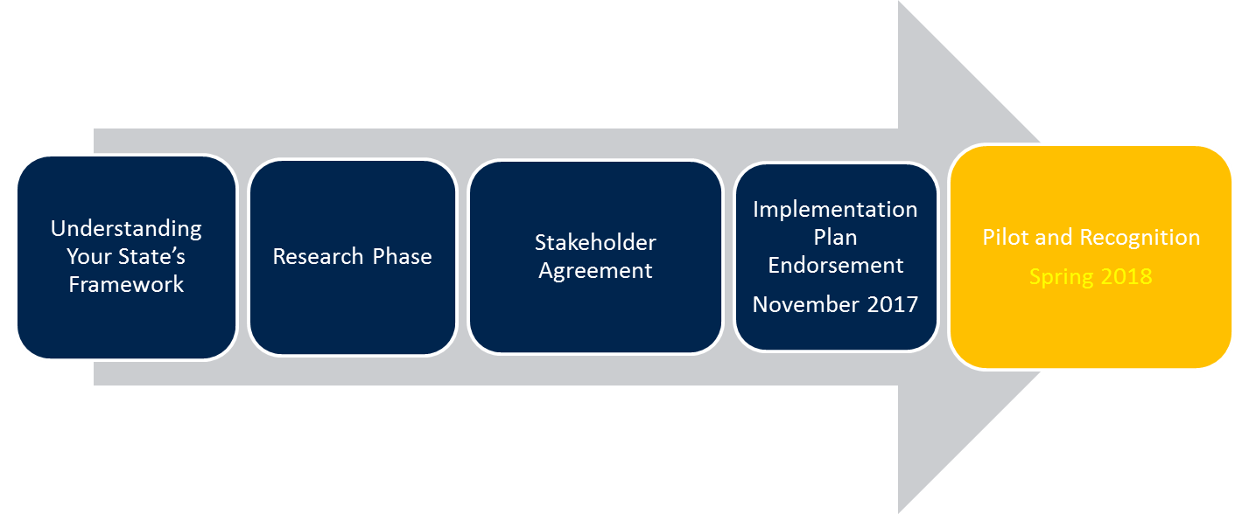**

This January, we started the first of three phases by surveying at the “Pediatric Ready” level with Pediatric Champion and Pediatric Innovator level in the next several months. We identified several facilities from a list of facilities that participated in the National Pediatric Readiness Project Survey in 2013. Hospitals from the 2013 survey were categorized based on the number of pediatric patients seen annually.

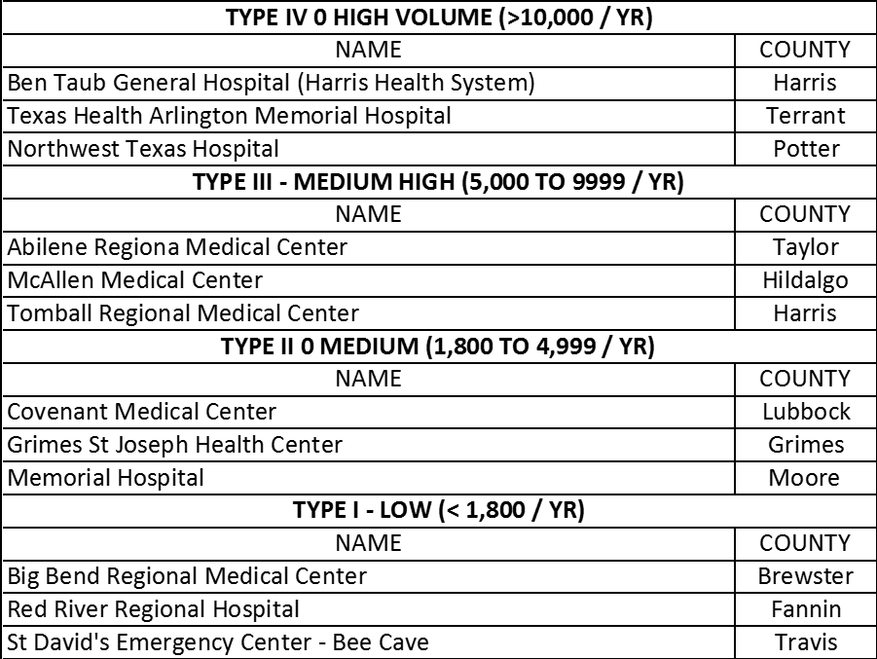

There are four different volume categories were based on a range of : less than 1800, 1800-4999, 5000 -9999, >10,000 peds patients annually. We will select three facilities from each category for a total of 12 for phase one and take the same approach for the other two levels. We plan on completing the first phase by August of this year and a report will be presented to the Pediatrics Committee at the upcoming November GETAC meeting.

ACTION ITEM: It was suggested that hospitals be identified as being part of a system or stand alone.

ACTION ITEM: Research the need for coaching for each hospital participating to help shore up need for expert assistance in certain areas e.g. KPI, etc. Currently, only EMSC staff identified as available resource(s).

ACTION ITEM: Research availability of resources to help facilities in search of training needs e.g. PALS classes.

ACTION ITEM: Research Potential Deal-breakers among facilities that may not be able to meet criteria.

ACTION ITEM: Include RAC and System Affiliation on the master list of hospitals for informational purposes.

1. **Voluntary Pediatric EMS Recognition Program (VPRP-EMS)**

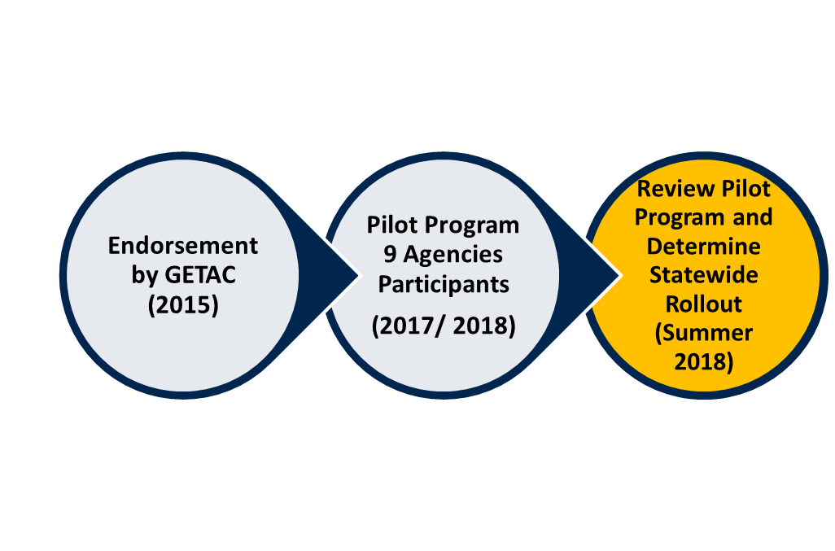Similar to the facility readiness program, we are concluding the pilot phase for the Voluntary EMS Readiness program for agencies who wish to improve their ability to deliver care to pediatric patients. The program has 3 levels: bronze, silver and gold. At the Bronze level, EMS agencies are required to have pediatric specific equipment, many of which are already mandated by the state.

The Silver level, required bronze level in addition to providing 4 pediatric specific CE hours per year. At the Gold level, agencies must meet the criteria for Bronze and Silver levels but must also demonstrate community involvement and outreach. Some examples include teaching pediatric CPR classes and educating communities about drowning prevention. The pilot included 9 agencies representing three different RACs and different locations throughout the state. All 9 agencies are being evaluated for the “Gold” level of readiness. 6 (highlighted below) of the 9 have completed the evaluation process and were award the Gold level of readiness:

|  |  |  |
| --- | --- | --- |
| BSA Hospital District | Dalhart EMS | Cedar Hill Fire Station |
| Booker EMS | Williamson County EMS | Texas EMS |
| Friendswood Fire Station | Clear Lake Emergency Corps | Montgomery County |

ACTION ITEM: Announce that agencies can submit application before May of 2018.

1. **Performance Measures 06 and 07 Re-assessment**

Our partners at the National EMSC Data and Resource Center (NEDARC) will be assisting all states in completing a national re-assessment that will examine the presence of Inter-Facility GUIDELINES and AGREEMENTS that cover pediatric patients within emergency departments throughout the state. Previously, Texas participated in a 2013 survey which reported that only 76% of ED’s have transfer guidelines while 74% of ED’s have agreements f with other hospitals for the transfer of patients of all ages including children in need of care not available at their facility. A total of 304 out of 504 hospitals responded to the 2013 survey and our goal is to get 80% of all ED’s in Texas to respond to this year’s survey.

1. **Family Advisory Network Representative**

* Created in 1999 by the EMSC program to facilitate the inclusion of family representatives in state EMSC programs
* Assures the needs of families are addressed when a child is in need of healthcare. Allows families to be part of the care team while providing support to the child.
* Participate in EMSC initiatives and assist state program in carrying out Program missions.
* Serve as advocates for better healthcare and services for children and families.
* Support children with special health care needs and their families.
* Sherry Santa, Texas Parent 2 Parent (EMSC FAN Representative)
* Sylvia Rodriquez, Interpreter (TCH), Parent of child with special needs.

Texas Parent to Parent (Sherry Santa, Medical Education Program Coordinator.

* Parents of children with disabilities, chronic illness and other special health care needs (including preemies)
* Small staff of full- and part-time employees (24) and many volunteers (need MORE!)
* Many years of experience providing parent-to-parent support
* Statewide nonprofit (§501 (c)(3)) headquartered in Austin

ACTION ITEM: Coordinate meeting with Sherry

1. **EMSC Crew of the Year Award**

Lastly, we are happy to announce that we are now accepting nominations for the 2018 EMS Crew of the Year Award that our program sponsors every year and presents on the Wednesday of National EMS Week, May 21 through the 26th. The award is given to an outstanding EMS crew or station who has displayed outstanding care for a child in an emergency medical or trauma event, development of pediatric training or QI programs, or creative injury prevention program.

1. **Grant Renewal Application 2018-2020**

We successfully submitted a grant application to HRSA, Maternal Health Branch that will fund the program for the next four years starting April 1st, 2018. We want to thank all the organizations and institutions for providing the EMSC program with letters of support and we anticipate a formal notification of our award prior to the start of the new grant cycle.

1. **Next EAC Meetings**

* May 9th, 2018 Austin, TX Venue TBD

1. **Meetings Adjourned: 04:00pm**